ESI QuickBooks AP Export

5/6/2005

Transaction controls
This transaction creates an IIF file that can be exported to QuickBooks Accounts Payable. The AP export dialog can be seen below.
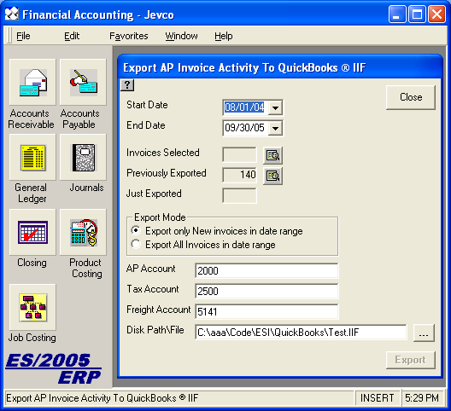
The controls on this form include:
- Start Date. You may type in a date, click the pulldown arrow to select from a calendar, or type an up-arrow / down-arrow to increase / decrease the date by one day. If you successfully export for this date, it is remembered the next time you select this transaction.
- End Date. You may type in a date, click the pulldown arrow to select from a calendar, or type an up-arrow / down-arrow to increase / decrease the date by one day. If you successfully export for this date, it is remembered the next time you select this transaction.
- Invoices Selected. This control shows the number of invoices selected with the current parameters. It changes each time you change the start date, end date, or export mode is changed.
- Show Selected Invoices button. Click this to see the invoices that will be exported if you click the Export button now.
- Previously exported. This shows the total number of invoices previously exported for the currently selected date range.
- Show Exported Invoices button. Click this to see the invoices that have already been exported. These are only invoices that have been placed in prior IIF files. There is no guarantee that you have actually imported these invoices into QuickBooks.
- Just exported. This shows the number of invoices exported after you click the Export button.
- Export mode. You may select to export only new invoices which have not been exported before or you may export all invoices in the date range. If you find fault with an IIF file and choose not to import it into QuickBooks, you may want to select all invoices in the date range to include the invoices from the prior aborted exports.
- AP Account. This is the accounts payable account that will be used in the export. The first time, it is taken from the company setup. After that it is remembered with each successful export. You may change it at any time.
- Tax Account. This is the tax account that will be used in the export. The first time, it is taken from the company setup. After that it is remembered with each successful export. You may change it at any time.
- Freight Account. This is the freight account that will be used in the export. The first time, it is taken from the company setup. After that it is remembered with each successful export. You may change it at any time.
- Disk Path/File. This is the location and file name of the IIF file that is to be created. You may type it in directly or click the “...” button to the right to select a path and/or file name. It is recommended that you code the dates into file names and never use the same file name twice. That way you can audit your exports.
- ... button. Click this button to select the location and file name of the export IIF file.
- Export button. Click this button to begin the export. This button is disabled if there are no invoices selected. If you have specified an existing file name, you will be asked if you wish to overwrite the previous file. It is recommended that you retain previous IIF files for auditing purposes.

The Export Process
When you click the Export button, the following steps occur:
- It is verified that you have specified all account and file information.
- If the destination IIF file exists, it is verified that you wish to overwrite it.
- All selected invoices are placed in the IIF file. You may view this file in Excel by double-clicking on it’s filename. The contents of an IIF invoice include:
- A line with the invoice parameters, invoice number, post date, total amount (shown as negative), vendor nickname, AP account, and due date.
- A line with the total for each expense/asset/cost account. Invoice individual line items are not retained, but there is a line with the total debit for each account.
- A line item with the freight debit.
- A line item with the tax debit.

The Import Process
Do a QuickBooks backup before performing your first import. If you don’t like the way the import creates data in QuickBooks, you may want to roll the database back.
QuickBooks allows import of pretty much any transaction as long as it balances. It is a good idea to examine the IIF file with Excel before you do the actual import. The following are issues to be dealt with.
If accounts do not exist, they will be created automatically, but the will be created as type “Bank”. You will need to revise these accounts to “Expense” or whatever is appropriate. It is best to have the accounts created in advance.
Vendors are created with the nickname in the IIF if they do not already exist under that code. Be careful to insure that nicknames and vendor names agree between the two systems. Otherwise, you will end up with split vendors each of which owns some of the invoices.
If you attempt to re-import an invoice you will see the following dialog:

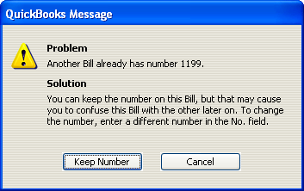

If you click “Keep Number”, a duplicate invoice will be inserted. If you click “Cancel”, you will see the following dialog. No duplicate invoice will be entered.

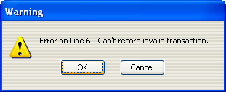

If you click “OK”, you will go on to the next invoice. If you click “Cancel”, no more invoices will be imported. You will see the following dialog:

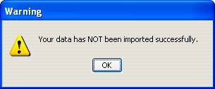

After the last invoice is successfully imported, you will see the following dialog.

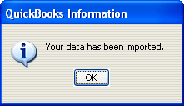

This means that you can process an import that includes prior invoices and avoid duplicate entries, although you must make this decision on an invoice-by-invoice basis.

